Rt Hon Mel Stride MP
Secretary of State for Work and Pensions
By email only

From: Baroness Kishwer Falkner, Chairwoman
Our ref: 2113Stride
Thursday 26 October 2023
Dear Secretary of State,

Consultation on Workplace Capability Assessment: activities and descriptors
I am writing to raise concerns about the potential impact on disabled people of your Department’s ongoing consultation on changes to the activities and descriptors in the Work Capability Assessment.
The Equality and Human Rights Commission is the independent equality regulator working across England, Scotland and Wales and a UN-recognised ‘A’ status National Human Rights Institution. This remit gives us a broad mandate to challenge discrimination and to promote and protect equality and human rights across a broad range of policy areas.
Our concerns about this consultation exercise relate to the duration of the consultation and the absence of any analysis in published documents of the potential impact of the proposals on disabled people and other protected characteristic groups.
Consultation period
As you know, the UK has ratified the UN Convention on the Rights of Persons with Disabilities (UNCRPD), and so is bound by international law to respect, protect and fulfil the rights it contains. This includes ensuring that disabled people are consulted closely with and actively involved in the development and implementation of relevant legislation, policies and decision-making processes (Article 4 (3)). This consultation is open for only eight weeks, having opened on 5 September and being due to close on 30 October. While we know the Department has supplemented the written consultation with a small number of in-person and online engagement events, we are concerned that the consultation period is insufficient to enable disabled people and their representative organisations to respond meaningfully.
Impact of proposals
Moreover, the published consultation materials do not include any analysis of the potential impact of the proposed changes on disabled people or other protected characteristic groups. As you are aware, the Department for Work and Pensions is subject to the Public Sector Equality Duty under the Equality Act 2010 and is required to have due regard to the need to eliminate unlawful discrimination and harassment, advance equality of opportunity, and foster good relations in the exercise of its functions, including at all stages of policy development. Without access to analysis of the possible equality implications of the proposals, it is challenging for disabled people and their representative organisations, and others, to engage with the consultation process.
Stakeholders have raised concerns with the Commission that the proposed changes, in particular the proposal to amend the ‘substantial risk’ criteria, could place disabled people at increased risk of both financial and psychological harm, with potentially serious equality and human rights implications. As such, the impact of the proposals on disabled people, including people with different types of impairment, warrants careful and detailed consideration.
We encourage you to extend the consultation deadline and to publish detailed analysis of the potential impacts of the proposals on disabled people and other protected characteristic groups to inform consultation responses. I would welcome the opportunity to meet with you to discuss this further as a matter of urgency.
I am copying this letter, for information, to the Minister for Disabled People
and the Minister for Employment.
Yours sincerely,
Baroness Kishwer Falkner
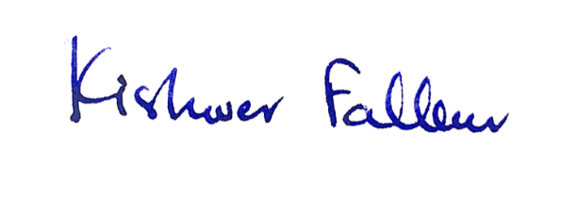
Chairwoman
Equality and Human Rights Commission |
[Cc: Tom Pursglove MP, Minister for Disabled People and Guy Opperman MP, Minister for Employment]

